EXPERIMENT 17

Create a Simple Python Flask API, Containerize the Application,
Build & Push the Image using Docker and Deploy the Application using Kubernetes

AIM
To create a simple Python Flask API, containerize the application using Docker, build and push the image to Docker Hub, and deploy and access the application using Kubernetes.

THEORY
Flask is a lightweight Python framework for creating web APIs. Docker packages the application and its dependencies into a portable image. Docker Hub provides a registry for storing and distributing images. Kubernetes orchestrates containers through Pods and Deployments and exposes applications using Services. A NodePort Service makes the Flask API reachable through a port on the Kubernetes node.

PROCEDURE
- Create the Flask project and write app.py with a basic JSON endpoint.
- Create requirements.txt and include Flask.
- Create a Dockerfile that installs dependencies, copies the application and starts the Flask server.
- Build the Docker image using Docker CLI.
- Tag the image with the Docker Hub repository name and push it to Docker Hub.
- Create deployment.yaml for the Flask application and specify the container port.
- Create service.yaml with Service type NodePort.
- Apply the Kubernetes Deployment and Service using kubectl.
- Verify the Pod and Service using kubectl get pods and kubectl get svc.
- Open the NodePort address in a browser and verify the API response.

IMPLEMENTATION
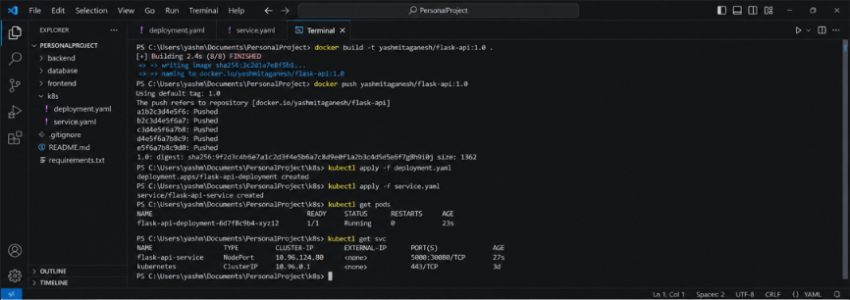
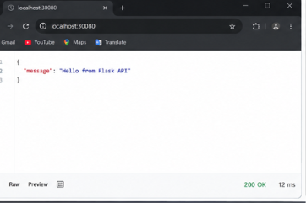
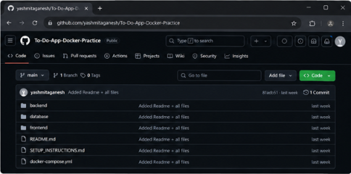

IMPLEMENTATION DETAILS
Parameter | Value
Project | PersonalProject / Flask API
Docker Image | yashmitaganesh/flask-api:1.0
Kubernetes Deployment | flask-api-deployment
Kubernetes Service | flask-api-service
Service Type | NodePort
Application Port | 5000
NodePort | 30080
Browser URL | http://localhost:30080/
Response | {"message": "Hello from Flask API"}
Status | 200 OK

OUTPUT
The Docker image was built and published, the Flask application was deployed as a Kubernetes Pod, and the NodePort Service exposed the API at localhost:30080. The browser returned the Flask JSON response with HTTP Status 200 OK.

RESULT
Thus, the Python Flask API was successfully containerized using Docker and deployed using Kubernetes. The application was exposed through a NodePort Service and verified through a web browser.

COMMANDS
docker build -t yashmitaganesh/flask-api:1.0 .
docker tag flask-api:1.0 yashmitaganesh/flask-api:1.0
docker push yashmitaganesh/flask-api:1.0
kubectl apply -f deployment.yaml
kubectl apply -f service.yaml
kubectl get pods
kubectl get svc

